Job Description

JOB TITLE: Haringey Wellbeing Network Activities Coordinator

RESPONSIBLE TO: Haringey Wellbeing Network Manager

Accountable to: Chief Executive Officer

HOURS: 30 hrs

SALARY: £24,000 per annum

Holidays: 28 days per year (Pro rata)

PURPOSE OF THE JOB

To support the Haringey Wellbeing network Manager to run the Activities service.

To carry out assessments for the Haringey wellbeing network service to ensure that all clients that are referred to the service are directed to relevant support and activities.

To implement and deliver activities programmes that maximise service user wellbeing, developing their social skills and confidence in a caring and accepting atmosphere.

To liaise with all facilitators of activities to ensure they adhere to our policies and procedures to deliver safe, skilled based activities that enhance service users’ wellbeing.

To manage volunteers that assist with delivering the wellbeing activities ensuring that they receive regular supervision and support.

DUTIES AND RESPONSIBILITIES

- To assist in ensuring the efficient running of the Activities element of the Haringey wellbeing network in line with Mind in Haringey’s current policies and maintain the operational guidelines, aims and objectives of the project.

- To assist in ensuring that all referrals are suitable for the Activities service and that service users have a plan of activities and risk assessment in place.

- To develop a programme of weekly wellbeing activities, manage and support their delivery ensuring efficient systems for smooth running of the service.

- To develop opportunities for service users by working with them to improve their Mental health and wellbeing or to meet immediate planned agreements around work and wellbeing activities.

- To liaise if required with social workers, hospitals, care coordinators, GP’s, DWP, housing departments and other relevant organisations or concerned parties.

- To provide general administrative support and monitoring data to line manager as required and keep records on VIEWS of all outcomes and outputs of the wellbeing activities, groups.

- To participate and present when required in team and staff meetings, Annual General Meetings and organisational social/educational activities as required.

- To attend supervision and handover sessions with the line manager and attend any training identified through supervision, or as directed.

- To share with all Mind in Haringey staff some occasional responsibility for tasks associated with the organisations campaigning, fundraising and educational activities.

- To work within Mind in Haringey’s policies, including Equal Opportunities, Open Files and Confidentiality, Health & Safety and User Involvement policies.

- To undertake any further tasks to ensure the smooth running of the Haringey wellbeing Network.

WELLBEING ACTIVITY CENTRE

- To assist in the management of the premises and maintaining a Covid – safe, relaxed, supportive atmosphere for service users. To ensure that health and safety procedures are followed.

- To assist the Haringey Wellbeing Network Manager in the development and delivery of a range of activities promoting wellbeing and recovery.

- To offer support to service users to enable them to achieve aims which they have defined for themselves in conjunction with staff.

- To participate in outreach work and the promotion of the service as identified and agreed by line manager.

- To help in the organisation with outings, service user forums, training and events that encourage development of independence and integration within the wider community.

- To supervise activities for the centre.

- To provide refreshments and meals engaging the members and volunteers within all aspects of the running of the service to minimise institutional stigma and promote co productive working.

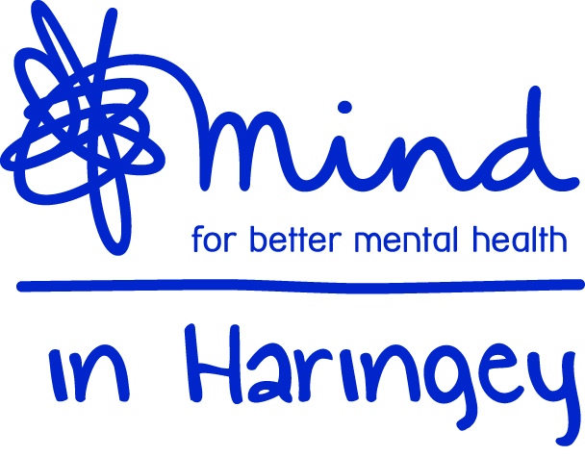

Haringey Wellbeing Network-Activities Coordinator

PERSON SPECIFICATION

EXPERIENCE
Essential:
- Two or more years’ experience of providing one to one and group support for people with mental health difficulties
- Knowledge of Welfare benefit payments
- Experience of group facilitation with diverse community members
- Voluntary or paid work which recognises the diversity of working in a multicultural community, committed to effective implementation of equal opportunities
- Experience of using database systems. Microsoft systems and digital platforms
- Experience of managing or supervising others
- Excellent verbal and written communications skills
- Experience of safeguarding Vulnerable adults at risk

Desirable:
- Experience of the various care practices for different levels of need eg. needs led approach, individual plan support work agreements
- Budgeting and/or fundraising experience

SKILLS/STYLE OF WORKING
Essential:
- Ability to motivate people
- Ability to identify stress levels of others and self and use appropriate support systems
- Ability to communicate effectively with colleagues and other agencies in a professional manner
- Ability to plan and work on own initiative
- Ability to work to targets and outcomes of the service
- Ability to supervise others
- Ability to interpret signals indicating a crisis and take appropriate action

KNOWLEDGE
Essential:
- A clear understanding of mental health and recovery
- Knowledge & understanding about the needs of those with mental health issues
- Knowledge and understanding of the needs of people from racialised communities
- Knowledge of mental health system or lived experience
- Knowledge of local resources and ability to refer people to other agencies

OTHER
Essential:
- Commitment to undertake appropriate training
- Willingness to participate in the general upkeep and maintenance of the Centre
- Commitment to the diverse needs of membership and able to offer a flexible approach to the issues of members.

