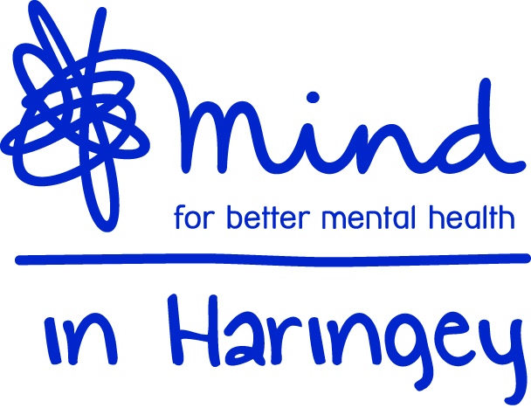

JOB DESCRIPTION

Telephone Support Line Worker

Salary: pro rata £24,300 per annum

Responsible to: Business Development Manager

Accountable to: Chief Executive Officer

Based at: Station House, 73c Stapleton Hall Road, N4 3QF /homebased work

Terms: 21 hours per week excluding breaks. Up to 6 months contract, may be extended

Hours: Monday to Friday 2pm-9pm Closing Date: Midday 4th May 2021 – Interviews 7th May

About Mind in Haringey

Mind in Haringey (established in 1984) is one of the leading mental health services in Haringey. We provide information, advice and support to anyone affected by a mental health problem, primarily in Haringey. We work to prevent mental health problems, promote mental wellbeing and ensure those with mental health problems are respected and included in our local community. One in four people are affected by metal health in Haringey, out of a population of 225,000 that's over 54,000 people. This includes 2,413 children and young people.

The services we offer include counselling (a daytime, evening and Saturday service), the Haringey Wellbeing Network service that includes Mental Health First Aid training and awareness community asset development, wellbeing advocacy, peer support and wellbeing activities such as gardening, ‘cooking on a budget’, yoga, meditation and a women’s craft and discussion group. We also deliver Project Future, a holistic mental health service working with young people involved in criminality.

Our services respond to needs identified by service users; working to increase wellbeing, confidence, social integration and independence. We work with more than 2000 carer’s, adults and young people suffering from or affected by mental ill health each year.

Our Values
- We listen with care, respect and reassurance to everyone we encounter
- We seek to influence and improve mental health services in Haringey, raising awareness and challenging both stigma and discrimination
- We are committed to easy and equal access for everyone in Haringey
- We consider opportunities for collaboration when developing services
- We seek continuous improvement in all we do

Summary

Mind in Haringey is seeking a Telephone Support Line worker(s) to assist to offer support and signposting to those Union representatives across the country supported by the Communication Workers Union (CWU).

The successful candidates will be responsible for providing telephone support and more crucially, signposting to the Employee Assistant Programmes (EAPs) available and other support provided by the CWU who will provide a directory of these organisations to refer to.

The successful candidate will be expected to provide this service from 2pm -9pm (shift pattern) Monday to Friday home based

You will have the opportunity to see at first hand the positive difference the service has for those reps as they access the support required.

Key Responsibilities

- To support individuals through the referral procedure, assessment of needs and follow up with appropriate signposting.
- To devise care/wellbeing plans for each service user.
- Signpost service users to other services (externally) where relevant to ensure they are receiving support that will be most beneficial to them (depending on their needs) and the wider community.
- To support individual recovery through the use of tools and relevant apps listed in directory.
- Work with and support project staff in monitoring outputs and outcomes.
- In conjunction with other members of the team, to actively encourage user participation and involvement in the planning, development and evaluation of the service.
- To work closely with our partners CWU to develop and maintain an effective and quality service.
- To maintain service user records and collect data as required by funders to support the analysis, audit and evaluation of the service and produce other written reports as required.
- To input data onto our service user data base.
- To participate in and complete all training relevant to the delivery of the service.
- To participate in regular line management supervision.
- To maintain standards of care with regard to health and safety, equal opportunities, confidentiality, individual and personal choice.
- To work within all Mind in Haringey’s policies and procedures at all times with specific reference to the Safeguarding of Vulnerable Adults and Child Protection policies.
- Undertake any other appropriate duties relevant to the post as directed from time to time by the Operations Service Manager.

About You

The successful candidate will be able to demonstrate that they have the following skills, abilities and/or experience gained from at least 2 to 3 years’ working within mental health and wellbeing settings with vulnerable adults.

E denotes an essential skill, ability or experience, D denotes a desirable skill, ability or experience:

- Demonstrable track record of supporting vulnerable people who suffer from mental health problems (E)
- A passion and commitment to helping people to become independent and live fulfilling lives (E)
- Experience of working on a wide variety of tasks and successfully prioritising them (E)
- Excellent interpersonal skills (E)
- Experience of project planning (D)
- Experience of working in a not for profit environment (D)
- The ability to write in clear, legible and coherent English (E)
- The ability to work with a range of people (E)
- You must have a commitment to team working and the ability to be a strong team player (E)
- The ability to work with minimal supervision, plan workloads and organise varied projects and activities (E)
- To be computer literate in a variety of software packages (E)
- You must possess good organisational and communication skills, including presenting oral and written reports (E)
- You must have a positive and solution orientated attitude (E)
- You must have a commitment to equal opportunities (E)

This post is subject to satisfactory enhanced DBS clearance

