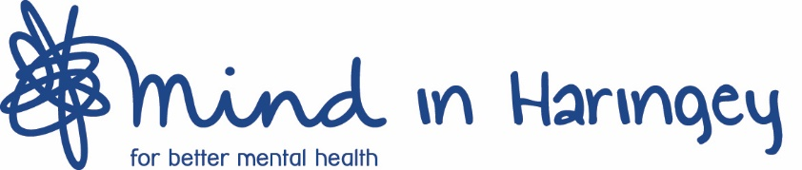

Mind in Haringey Job Description and Person Specification

Title of Post: Triage and Assessment Project Worker

Responsible to: Haringey wellbeing service Manager

Accountable to: CEO

Location: Mind in Haringey, Stapleton Hall Road, London N4

Salary: £22,000 pro-rata

Part time: 22.5 hrs. per week

Annual Leave: 17 day (due to pro-rata)

Role Description – Triage and Assessment Project Worker

Purpose of job role
To develop, co-ordinate and deliver assessment and administrative procedures, systems to support the Haringey wellbeing network services and work of Mind in Haringey.
To ensure with the service manager the smooth and efficient running of the Haringey wellbeing network using the EAST principles

Specific Duties

Administration, Data entry & Triage
To be the first point of contact for all enquiries to Haringey wellbeing network including the website, email, and telephone; dealing with enquiries, completing initial screening/referral of callers to the service.

To assess the eligibility of referrals and enquiries received into the Haringey Wellbeing Network and to allocate/triage cases appropriately.

To review and maintain recording procedures and systems via VIEWS database ensuring accurate records are kept.

To co-ordinate and deliver all administration duties within Haringey wellbeing network service and be its services including reception and clerical duties.

To provide up to date information to the service manager to ensure that the reporting and activity records for the service are meeting contractual requirements.

To contribute to the Haringey Wellbeing Network assessment process, by undertaking non-complex assessments.

Flexibility
To be able to attend meetings or other activities to ensure efficiency of service.

Monitoring and Evaluation
To co-ordinate and maintain evaluation and monitoring systems as advised by service manager and produce reports for Haringey wellbeing network service manager and service users.

This to include:
- client monitoring tracking and systems
- demographics and data relating to people affected by mental health in Haringey
- commissioning reports
- and other informative databases

Line management responsibility
Volunteers

Volunteers
To co-ordinate volunteer admin roles, support and provide support and administration tasks.

Other
Any other tasks as may be reasonably required by the service Manager.
To act always in the best interest of the Mind in Haringey and the Haringey wellbeing network service.

To fully understand and comply with Mind in Haringey’s Equality and Diversity Policy.

General
Adhere to Mind in Haringey’s Equal Opportunities and Diversity policies always.
Adhere to & Mind in Haringey’s Safety and Confidentiality policies at all times.

This job description covers the current range of duties and will be reviewed from time to time. It is Mind in Haringey’s aim to reach agreement on changes, but if agreement is not possible, Mind in Haringey reserves the right to change this job description.

Application:

Job Application Deadline: Tuesday 6th April 2021

Interviews: Friday 9th April 2021

Please return all applications to: admin@mih.org.uk

PERSON SPECIFICATION : Triage and Assessment Project Worker

Experience and track record

Essential

Demonstrable practical administration skills within an office-based environment
Excellent verbal and written communications skills
Demonstrable IT skills within an office-based environment including Excel, Microsoft Outlook, Microsoft Word and PowerPoint and VIEWS database
Excellent organisational skills and diary management
Confident and motivated in role
Ability to maintain excellent relationships with internal staff and external agencies
Ability to work using own initiative
Ability to work under pressure to meet conflicting deadlines
Understanding and commitment to Equality and Diversity policy.

An understanding of assessment and monitoring processes

Ability to work as part of a multidisciplinary team

Desirable

Understanding of mental health issues.

Application:

Job Application Deadline: Tuesday 6th April 2021

Interviews: Friday 9th April 2021

Please return all applications to: admin@mih.org.uk

