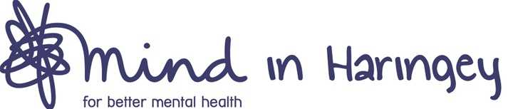

BECOME A CHARITY TRUSTEE

Mind in Haringey is looking to recruit new Trustees to join our Board of Trustees. Our charity has an ambitious agenda and is committed to reducing the racial and health inequalities that exist in Haringey. We support all people across the borough with mental health issues, providing a range of services to meet the diverse needs of our community.

Now before you decide not to read on, this opportunity really could be for you. We wish to make the Board more reflective of the diversity of the Haringey population and are looking for people from our black and minority ethnic community in particular. We would especially welcome those who have been carers and those who have experienced mental illness and/or have used mental heath services.

Your commitment, energy and interest in helping those with mental health issues in Haringey is the key to this role.

The Board of Trustees has agreed the strategy for the charity and oversees its implementation by our committed staff and volunteers. The Board is also responsible for ensuring that the charity fulfils its responsibilities for the governance of the organisation and for the finances of the charity.

There are currently eight Trustees from different age groups and professional backgrounds with varying experiences of mental health on the Trustee Board. We meet every two months in the early evening.

The Trustee role is really rewarding. We offer induction and training and this could be your chance to help make a difference to mental health in Haringey.

Please send your CV and a short covering statement to us by Monday 15th February 2021, explaining your interest.

