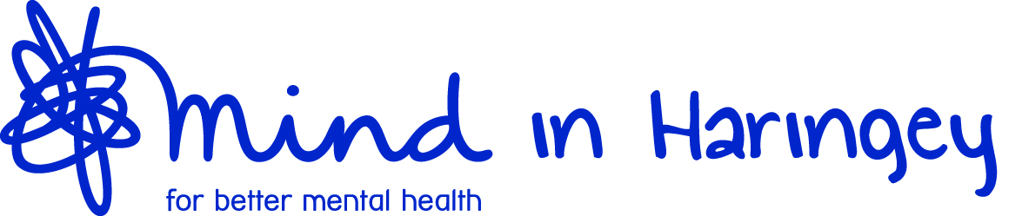

Job Title: Digital Marketer
Reports to: Office Manager
Salary: £12 per hour
Hours: 15 hours
Summary of Role:
This is an exciting opportunity to join an award-winning Mental Health Charity with over 45 years' of experience working across Haringey, supporting the wellbeing and mental health of our diverse community. There has never been a better time to join Mind in Haringey with lots of new and exciting services and projects to deliver!
The role would suit someone who has a flare for design, passion for social media and proficient with all major social media platforms. Plus, social media management tools to work with in promoting our services to our residents, volunteers and frontline workers. Your skills will make a difference to our community!
Main Duties and Responsibilities;
- Create and develop engaging content about Mind in Haringey and its activities for social media platforms.
- Develop, manage and forward plan social media marketing and post accordingly to increase the visibility of our services/projects and social content.
- Maintain consistency of brand and voice across all social media platforms, communications and the website.
- Monitor and report on social media channels for industry trends.
- Keep the website up-to-date and active.
- Take the lead on any digital projects that may arise.
The Successful Candidate should have/ be:
- Creative and outgoing
- Excellent writing, editing (photo/video/text), presentation and communication skills.
- Positive attitude with good multitasking and organisational ability.
- Detail orientated with a high level of accuracy.
- Create and upload copy and images for the organisation's website.
- Manage the contact database and assist with lead generation activities.
- Able to work to deadlines, without compromising on quality.
- General IT and admin skills are useful.

